·:Lpath CONTROLLED FORM INCORPORAT I P TITLE: GXP and Non-GXP Study Report Review and Approval Fonn DOCUMENT NO. VERSION ISSUE DATE EFFECTIVE DATE PAGE GE003FM01 I 02 I 17 Oct 2014 I 20 Oct 2014 I 2 of2 o vendor Study Protocol O vendor Study Report [{] Lpath Study Report —-, Lpath Study No.: LT 3114-PHA-016-R Version No.: 0/ {Non GXP GLP i== r—’ GCP GMP Product Name: L T3114 Test Article: 83; LT 3114 Study Title: Direct and competitive binding of anti-LPA antibodies 83 and LT 3114 Study Vendor/Site: U NJA I Study Director: UN/A I Study Contributor(s): U NJA LPath Rosalia Matteo Kelli Moreno Vendor Study No.Nersion: [{]NjA Study Dates: Report Date: 2007 Nov 2014 Lab Notebook Reference: LNB#312, pp5-6; LNB#301, pp102-103; LNB#220, p81 QJ/A Executive summary of study results: O see Attached UN/A Lpath has developed murine and humanized monoclonal antibodies targeting LPA. This report covers development of ELISA methods that are both sensitive and specific for Acyl chain LPA isoforms. The Ki of both the murine and humanized antibodies range from 15.8 nM to 986nM for all of the isoforms tested LPATI:I AJ>PROVAL Function Name (Print) Signature Date Study Director/Monitor \2.n <..a I Cl.- M a .:tr r o ( ~Ytd.J-<–c)J- It f r ~ ). “). oll.f Contributor tJA- .—; tJ~ tft:) It /7, ‘1-/?c:.iY Research CiA-Je’1 ~~ ~~ a &>7 n )A- II If g, I u l’f’ I/ Development ~,. fttt;lrl,.,.,’tJo ~ /lf/Z0!2 Quality Assurance R ht// /lA Ml9r2tfl.V &’2- ./,,,_ _ J d A-. ;z~ I u~P/7’ v J CONFIDENTIAL
Table (source: module4_extracted/Direct and Competitive Binding of anti-LPA antibodies B3 and LT3114/tables/table_page_1_idx_1.csv)
·:Lpath CONTROLLED FORM INCORPORAT I P
TITLE: GXP and Non-GXP Study Report Review and Approval Fonn
DOCUMENT NO. VERSION ISSUE DATE EFFECTIVE DATE PAGE003FM01 I 02 I 17 Oct 2014 I 20 Oct 2014 I 2 of2
Table (source: module4_extracted/Direct and Competitive Binding of anti-LPA antibodies B3 and LT3114/tables/table_page_1_idx_2.csv)
o vendor Study Protocol O vendor Study Report [{] Lpath Study Report
None
None
None
None
None
None
None
None
None
Lpath Study No.: LT 3114-PHA-016-R
None
Version No.: 0/
None
None
—-,\n{Non GXP=—’ GCP
None
None
=
GLP
Product Name: L T3114
None
Test Article: 83; LT 3114
None
None
None
None
None
None
None
Study Title: Direct and competitive binding of anti-LPA antibodies 83 and LT 3114
None
None
None
None
None
None
None
None
None
Study Vendor/Site: U NJA I Study Director: UN/A I Study Contributor(s): U NJARosalia Matteo Kelli Moreno
None
None
None
None
None
None
None
None
None
Vendor Study No.Nersion: [{]NjA
None
None
Study Dates:
None
None
Report Date:
None
None
None
Lab Notebook Reference: LNB#312, pp5-6; LNB#301, pp102-103; LNB#220, p81 QJ/A
None
None
None
None
None
None
None
None
None
Executive summary of study results: O see Attached UN/Ahas developed murine and humanized monoclonal antibodies targeting LPA. This report covers development ofmethods that are both sensitive and specific for Acyl chain LPA isoforms. The Ki of both the murine andantibodies range from 15.8 nM to 986nM for all of the isoforms tested:I AJ>PROVAL
None
None
None
None
None
None
None
None
None
Function
Name (Print)
None
None
Signature
None
None
Date
None
None
Study Director/Monitor
\2.n <..a I Cl.- M a .:tr r o
None
None
( ~Ytd.J-<_–c)J-
None
None
It f r ~ ). “). oll.f
None
None
Contributor
tJA-
None
None
_.—; tJ~
None
None
tft:) It /7, ’1-/?c:.iY
None
None
Research
CiA-Je’1 ~,. fttt;lrl,.,.,’tJo
None
None
~~ a _n )A-
None
None
II If g, I u l’f’//lf/Z0!2_
None
None
Development
None
None
None
&>7~
None
None
None
None
None
Quality Assurance
R ht// /lA Ml9r2tfl.V
None
None
&’2- ./,,,_ _ J d A-.
None
None
I;z_{u}P/7’
None
None
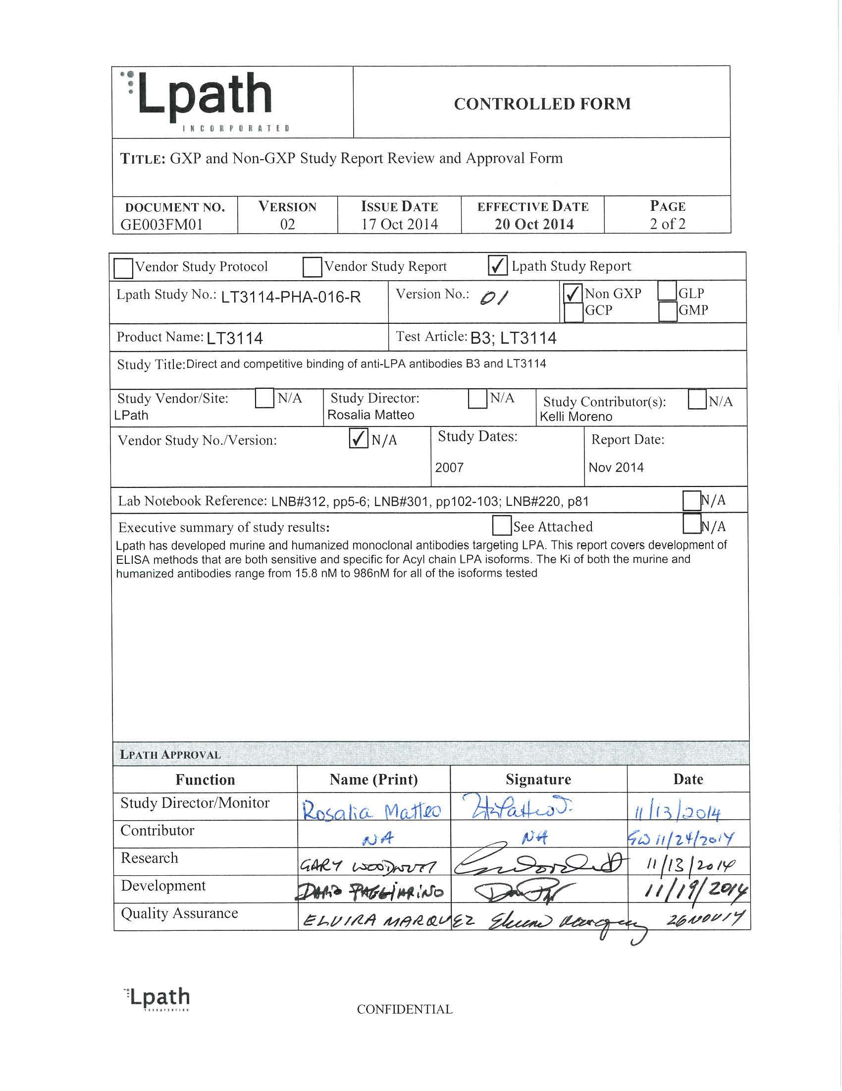
Image page 1 #1

Image page 1 #2
REPORT NUMBER: LT3114-PHA-016-R Title: Direct and Competitive Binding of anti-LPA Page 1 of 8 antibodies B3 and LT3114 Direct and Competitive Binding of anti-LPA antibodies B3 and LT3114 Document Type Final Repot Study Monitor Rosalia Matteo Study Director Kelli Moreno Performance Site (s) Lpath Initiation Date 2007 Completion Date 2007 Date FSR 10-2014 2014 GLP, GMP or GCP Non-GLP Number of Pages 8 Description Test Article Murine Anti-LPA antibody(B3) and humanized anti-LPA antibody (LT3114) Archive Lpath CONFIDENTIAL
Table (source: module4_extracted/Direct and Competitive Binding of anti-LPA antibodies B3 and LT3114/tables/table_page_2_idx_1.csv)
0
1
REPORT NUMBER: LT3114-PHA-016-R: Direct and Competitive Binding of anti-LPAB3 and LT3114
Page 1 of 8
REPORT NUMBER: LT3114-PHA-016-R Title: Direct and Competitive Binding of anti-LPA Page 2 of 8 antibodies B3 and LT3114 TABLE OF CONTENTS 1 SUMMARY ………………………………………………………………………………………………………..3 2 INTRODUCTION ……………………………………………………………………………………………….3 3 MATERIALS AND METHODS ……………………………………………………………………………4 3.1 Test Article and Control……………………………………………………………………………….4 3.2 Study Design ………………………………………………………………………………………………4 3.3 Direct Binding ELISA …………………………………………………………………………………4 3.4 Competition ELISA …………………………………………………………………………………….4 3.5 Data Analysis ……………………………………………………………………………………………..5 4 RESULTS …………………………………………………………………………………………………………..5 5 CONCLUSION ……………………………………………………………………………………………………8 6 DATA ARCHIVE ………………………………………………………………………………………………..8 LIST OF IN-TEXT TABLES Table 1 The Ki for each antibody binding to native LPA isoforms. …………………….7 LIST OF IN-TEXT FIGURES Figure 1. Binding Curves For B3 (A) and LT3114 (B)………………………………………..6 Figure 2 Affinity of anti-LPA antibodies for various LPA isoforms. Affinities of the antibodies for native 16:0, 18:0, 18:1, 18:2, and 20:4 were measured in an ELISA-based competition binding assay……………………….7 CONFIDENTIAL
Table (source: module4_extracted/Direct and Competitive Binding of anti-LPA antibodies B3 and LT3114/tables/table_page_3_idx_1.csv)
0
1
REPORT NUMBER: LT3114-PHA-016-R: Direct and Competitive Binding of anti-LPAB3 and LT3114
Page 2 of 8
REPORT NUMBER: LT3114-PHA-016-R Title: Direct and Competitive Binding of anti-LPA Page 3 of 8 antibodies B3 and LT3114 1 SUMMARY Lpath has developed murine and humanized monoclonal antibodies targeting LPA. This report covers development of ELISA methods that are both sensitive and specific for Acyl chain LPA isoforms. The Ki of both the murine and humanized antibodies range from 15.8 nM to 986nM for all of the isoforms tested 2 INTRODUCTION Lysophosphatidic acid (LPA) is not a single molecular entity but a collection of structural analogs with a single functional glycerol alcohol phosphate moiety esterified to a variety of fatty acyl hydrocarbons of varied lengths and degrees of saturation. LPA species with both saturated (16:0 and 18:0) and unsaturated fatty acids (16:1, 18:1, 18:2, and 20:4) have been identified in biological fluids with 16:0, 18:1 18:2 and 20:4 LPA being the predominant species. Lpath has generated murine and humanized monoclonal antibodies to lysophosphatidic acid and this report describes data showing that these antibodies bind to all of the relevant isoforms of LPA. CONFIDENTIAL
Table (source: module4_extracted/Direct and Competitive Binding of anti-LPA antibodies B3 and LT3114/tables/table_page_4_idx_1.csv)
0
1
REPORT NUMBER: LT3114-PHA-016-R: Direct and Competitive Binding of anti-LPAB3 and LT3114
Page 3 of 8
REPORT NUMBER: LT3114-PHA-016-R Title: Direct and Competitive Binding of anti-LPA Page 4 of 8 antibodies B3 and LT3114 3 MATERIALS AND METHODS 3.1 Test Article and Control Murine anti-LPA antibody (504B3; B3) Lot # HR121456 Humanized anti-LPA antibody (LT3114) Lot # LP121425 3.2 Study Design Development of both direct and competition ELISA format assays to demonstrate binding and specificity of anti-LPA antibodies to LPA ligands. 3.3 Direct Binding ELISA The assay uses thiolated C12-LPA conjugated to BSA as the capture agent for the direct format ELISA. Ninety six well plates were coated with 100 µl of 1 µg/ml of C12 LPA-BSA- SMCC for 1 hour at 37 degrees. The plates were washed 4 times with PBS and blocked with 150 µl of PBS-BSA-Tween for 1 hour at room temperature. 100 µl of B3 or 3114 antibody was added starting at 4 µg/ml and diluted 2-fold across the plate for the standard curve. Plates were incubated at room temperature for 1 hour. Next, plates where washed 4 times with PBS and 100µl of a peroxidase conjugated anti-mouse IgG (H+L) (Jackson immunoresearch 115-035-062) or anti-human IgG (H+L) (Jackson immunoresearch 709-035- 149) was added at a 1:40K dilution and incubated for 1 hour at room temperature. Finally, the plates were washed four times with PBS and developed with 100 µl cold TMB substrate for 12 minutes at room temperature. The reaction was stopped with 100 µl of 1M H2SO4. Plates were read at 450 nm. 3.4 Competition ELISA The specificity and binding of the murine (B3) and humanized (LT3114) anti-LPA monoclonal antibodies were determined by competition ELISA. For LT3114 competition, goat anti-human IgG (Jackson Immunoresearch, Cat#109-005-098, Lot # 90887) was diluted to 1 µg/mL in carbonate buffer (100 mM NaHCO3, 33.6 mM Na2CO3, pH 9.5) and 15 uL/well of the coating solution was added to 384 well plates and incubated overnight at 4°C. The following day, the plates were blocked with 60 µL/well PBS + 1% BSA + 0.1% Tween-20 for 1 hour at room temperature. The human 3114 antibody was diluted to 50 ng/mL in PBS +0.1 % Tween-20 and 15 µL/well were added and incubated for 1 hour at room temperature. Then, the plates were washed 4X with PBS and incubated for 2 hour at room temperature with 15 µL/well LPA-biotin (20 nM) /unlabeled (2000 to 0.1 nM) lipid mixture. Next, plates were washed 4X with PBS and 15 µL/well SA-HPX 1/30,000 was added and incubated for 15 min at room temperature. Again the plates were washed 4X with PBS and 15 µL/well cold TMB substrate was added. After 5 minutes, the reaction was stopped with 1M H SO . The optical density (OD) was measured at 450 nm using a Thermo 2 4 CONFIDENTIAL
Table (source: module4_extracted/Direct and Competitive Binding of anti-LPA antibodies B3 and LT3114/tables/table_page_5_idx_1.csv)
0
1
REPORT NUMBER: LT3114-PHA-016-R: Direct and Competitive Binding of anti-LPAB3 and LT3114
Page 4 of 8
REPORT NUMBER: LT3114-PHA-016-R Title: Direct and Competitive Binding of anti-LPA Page 5 of 8 antibodies B3 and LT3114 Multiskan EX. Raw data were transferred to GraphPad software for analysis. Values for percent inhibition were calculated for each lipid using Microsoft Excel. For B3 competition the same method was followed but Jackson Immunoresearch goat anti- mouse IgG, (Cat#115-005-071, Lot# 91365) was used to coat the plates. 3.5 Data Analysis The plates were read on Thermo multiscan EX plate reader at an absorbance of 450 nm. Raw data was recorded directly by Ascent software for the Multiscan plate reader. Preliminary calculations and statistical analysis were performed either in Graphpad Prizm or Excel software. 4 RESULTS Binding of Anti-LPA antibodies to LPA by Direct ELISA The murine mAb used for proof-of-concept studies in animal models of neuropathic pain (designated B3) and the humanized variant (LT3114) shows similar binding characteristics by direct ELISA. Binding curves were comparable and all fit well to the 4-parameter model with a Hill slope of ~1 and narrow 95% confidence limits for comparable EC50 (33.5 ng/ml for B3 and 24.4 ng/ml for LT3114) (Figure 1, A and B). Binding Affinities of Anti-LPA antibodies to LPA Isoforms by Competition ELISA The competition binding ELISA was used to compare the affinity of the murine (B3) and humanized (LT3114) antibody for different isoforms of LPA. Figure 2 shows the competition binding curves for 16:0, 18:0, 18:1, 18:2 and 20:4 LPA isoforms. The humanized antibody, LT3114, and the murine antibody, B3, from which the LT3114 CDRs were obtained, have essentially identical binding characteristics for native lipid, with a Ki of 16 nM for 18:2 LPA, 360 nM for 18:1 LPA (Table 1). CONFIDENTIAL
Table (source: module4_extracted/Direct and Competitive Binding of anti-LPA antibodies B3 and LT3114/tables/table_page_6_idx_1.csv)
0
1
REPORT NUMBER: LT3114-PHA-016-R: Direct and Competitive Binding of anti-LPAB3 and LT3114
Page 5 of 8
REPORT NUMBER: LT3114-PHA-016-R Title: Direct and Competitive Binding of anti-LPA Page 6 of 8 antibodies B3 and LT3114 Figure 1. Binding Curves For B3 (A) and LT3114 (B) A B CONFIDENTIAL
Table (source: module4_extracted/Direct and Competitive Binding of anti-LPA antibodies B3 and LT3114/tables/table_page_7_idx_1.csv)
0
1
REPORT NUMBER: LT3114-PHA-016-R: Direct and Competitive Binding of anti-LPAB3 and LT3114
Page 6 of 8
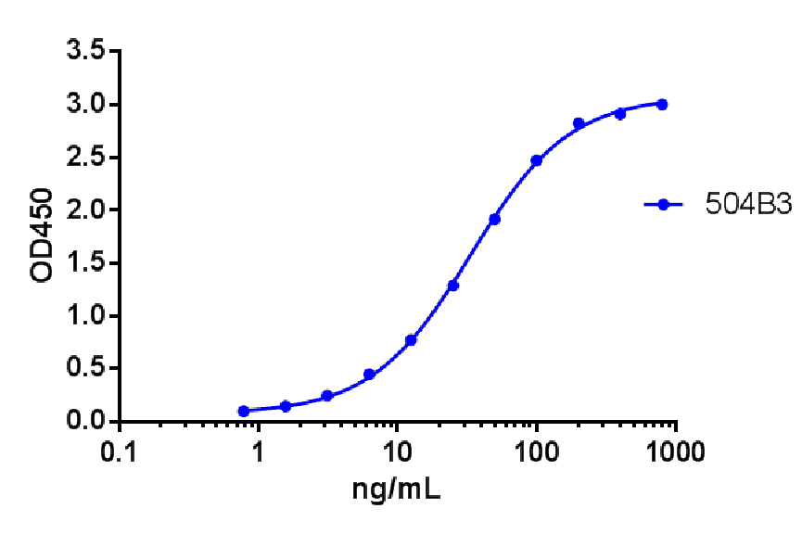
B
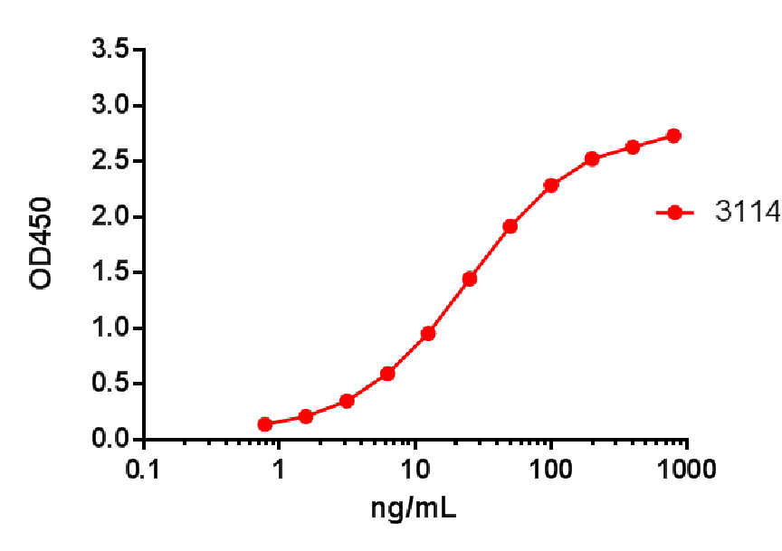
Image page 7 #2
REPORT NUMBER: LT3114-PHA-016-R Title: Direct and Competitive Binding of anti-LPA Page 7 of 8 antibodies B3 and LT3114 Figure 2 Affinity of anti-LPA antibodies for various LPA isoforms. Affinities of the antibodies for native 16:0, 18:0, 18:1, 18:2, and 20:4 were measured in an ELISA-based competition binding assay. Table 1 The Ki for each antibody binding to native LPA isoforms. Ki for each of the lipids was determined by fitting the competition binding data using the formula of Cheng and Prusoff in GraphPad Prism software and the Kd of each antibody for the biotin-labeled LPA determined in a separate saturation binding ELISA experiment CONFIDENTIAL
Table (source: module4_extracted/Direct and Competitive Binding of anti-LPA antibodies B3 and LT3114/tables/table_page_8_idx_1.csv)
0
1
REPORT NUMBER: LT3114-PHA-016-R: Direct and Competitive Binding of anti-LPAB3 and LT3114
Page 7 of 8
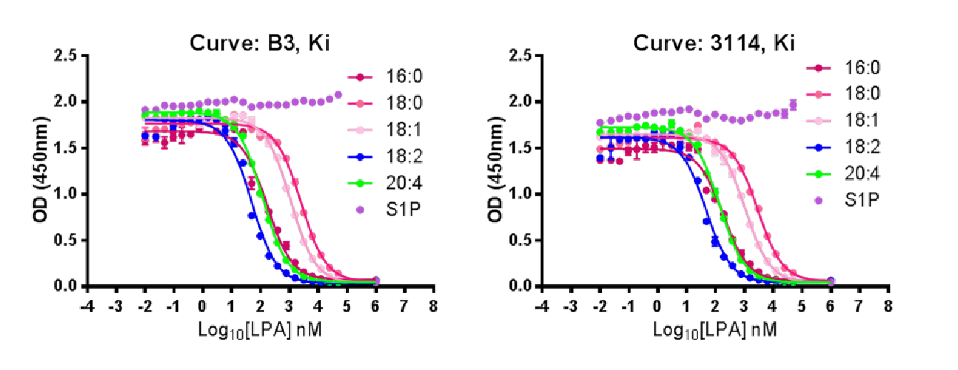
Table 1 The Ki for each antibody binding to native LPA isoforms.
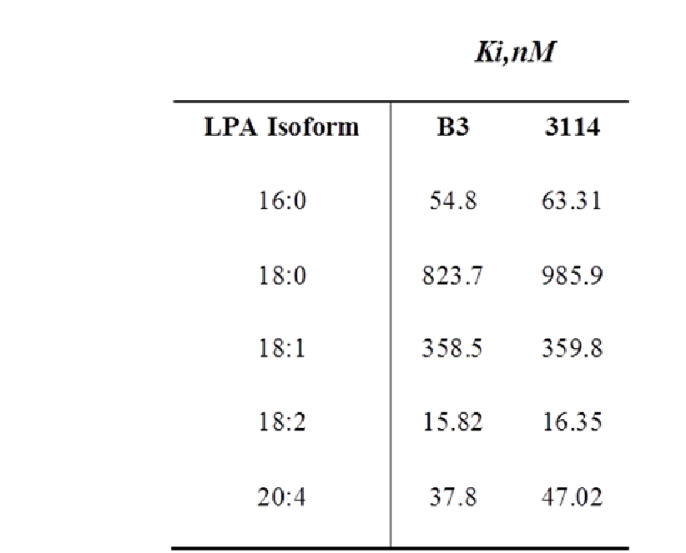
Ki for each of the lipids was determined by fitting the competition binding data using the formula of Cheng and Prusoff in GraphPad Prism software and the Kd of each antibody for the biotin-labeled LPA determined in a separate saturation binding ELISA experiment
REPORT NUMBER: LT3114-PHA-016-R Title: Direct and Competitive Binding of anti-LPA Page 8 of 8 antibodies B3 and LT3114 5 CONCLUSION We have generated potent and specific mouse (B3) and humanized (LT3114) neutralizing antibodies that bind to a wide range of physiologically relevant LPA isoforms. 6 DATA ARCHIVE B3 Binding direct ELISA: Lpath Notebook #312, pp 5-6 3114 Binding by direct ELISA: Lpath Notebook #301, pp 102-103 Affinity data: Lpath Notebook #220, p81 CONFIDENTIAL
Table (source: module4_extracted/Direct and Competitive Binding of anti-LPA antibodies B3 and LT3114/tables/table_page_9_idx_1.csv)
0
1
REPORT NUMBER: LT3114-PHA-016-R: Direct and Competitive Binding of anti-LPAB3 and LT3114
Page 8 of 8

